# ABSTRACT



iv

## ABSTRACT

TUNE IN musical website is dedicated to all music enthusiasts, providing a platform for music lovers to explore, discover, and connect with new artists and songs. With a comprehensive library of musical genres ranging from classical to pop, the website caters to a diverse audience. Users can create custom playlists, follow their favorite artists, and receive recommendations based on their listening history. The site also features news, reviews, and interviews with industry experts and emerging artists, keeping users up-to-date with the latest in the music world. In addition, the website provides a secure and user-friendly online marketplace for musicians to sell their music, connect with fans, and grow their fanbase. Whether you're a casual listener or an avid music collector, this website has something for everyone. So come and join the musical journey**!**

# TABLE OF CONTENTS



**TABLE OF CONTENT**

|  |  |  |
| --- | --- | --- |
| **CHAPTER.NO** | **TITLE** | **PAGE NO** |
| 1 | **INTRODUCTION** | **1** |
|  | 1.1 PROBLEM STATEMENT | 2 |
|  | 1.2 OVERVIEW | 2 |
|  | 1.3 OBJECTIVE | 2 |
| 2 | **SYSTEM SPECIFICATIONS** | **3** |
| 3 | **PROPOSED SYSTEM** | **5** |
|  | 4.1 PROPOSED SYSTEM | 5 |
|  | 4.2 ADVANTAGES | 6 |
| 4 | **METHODOLOGIES** | **7** |
|  | 4.1 LOGIN PAGE | 8 |
|  | 4.2 HOME PAGE | 8 |
|  | 4.3 SEARCH BY ARTISTS | 9 |
|  | 4.4 ABOUT US | 9 |
|  | 4.5 COMMENT PAGE | 10 |
| **5** | **IMPLEMENTATION AND RESULT** | 11 |
| **6** | **CONCLUSION AND FUTURE SCOPE** | **32** |
|  | 7.1 CONCLUSION | 32 |
|  | 7.2 FUTURE SCOPE | 32 |
| **7** | **REFERENCES** | **33** |

# LIST OF FIGURES



vi

**LIST OF FIGURES**

|  |  |  |
| --- | --- | --- |
| **FIGURE NO** | **TITLE** | **PAGE NO** |
| 4.1 | Process flow diagram | 7 |
| 4.2 | Login page flowchart | 8 |
| 4.3 | Comments page flowchart | 10 |
| 5.1 | Login page | 11 |
| 5.2 | Home page | 12 |
| 5.3 | Singers | 13 |
| 5.4 | Musicians | 13 |
| 5.5 | Java Script Alert | 14 |
| 5.6 | About us | 15 |
| 5.7 | Comments page | 16 |
|  |  |  |

# LIST OF ABBREVIATIONS



vii

### LIST OF ABBREVIATIONS

|  |  |
| --- | --- |
| ABBREVATIONS | ACRONYMS |
|  |  |
| HTML | Hyper Text Markup Language |
| CSS | Cascading Style Sheet |
| JS | JavaScript |
| VS | Visual studio |

# INTRODUCTION



## CHAPTER 1 INTRODUCTION

This chapter we are going to see the problem statement , overview and objective of the musical website

The musical website is a one-stop destination for music lovers. With a vast library of songs from different genres, artists, and cultures, it offers an extensive collection of music that caters to the diverse taste of its users. The website has a user-friendly interface that enables users to easily search and find the music they desire. The site also provides high-quality audio streaming, as well as options for downloading tracks for offline listening. Whether you're a fan of classical music, rock, pop, hip-hop, or any other genre, this musical website has something for everyone. So, whether you're looking for new music to add to your collection, or just want to stay up-to-date with the latest musical trends, this website is the perfect place to be. The website is a platform for music lovers, offering a diverse collection of songs from various genres, artists, and cultures. It features a user-friendly interface, allowing users to easily navigate and find the music they desire. The site offers high-quality audio streaming, as well as options for downloading tracks for offline listening. In addition to music, the site also provides updated news and reviews on the latest albums, concerts, and events in the music industry. The site also features a social community aspect, allowing users to connect with other music fans, share playlists, and participate in discussions. Whether you're a casual listener or a passionate music connoisseur, this website is the ultimate destination for discovering new sounds, keeping up with the latest music trends, and sharing your love for music with others.

### PROBLEM STATEMENT

Users should be able to create and save their own playlists and add new songs to them. Users should be able to stream music from the website and listen to it in high quality. The website should provide music news, reviews, and interviews with artists to keep users updated on the latest music trends.

### OVERVIEW

An musical website is a platform that provides users with access to a vast library of music and other musical content, such as news, reviews, and playlists. The main goal of a musical website is to offer users an immersive and engaging music experience, where they can discover new music, stream their favorite tracks, and connect with other music enthusiasts.

### OBJECTIVE

To provide a vast music library that includes a wide variety of genres and artists. To offer high-quality audio streaming of music to ensure a great listening experience for users. To allow users to create and save their own playlists, making it easy to access their favorite music anytime. To provide music recommendations and playlists based on users' preferences and listening history. To offer up-to-date music news and reviews to keep users informed about the latest trends and developments in the music industry.

# SYSTEM SPECIFICATION



## CHAPTER 2 SYSTEM SPECIFICATION

This chapter gives you a small description about the softwares used in the project.

### 2.1 VS CODE

### Visual Studio Code (often called simply "VS Code") is a popular, free, and open-source code editor developed by Microsoft. It supports a wide variety of programming languages and provides features such as syntax highlighting, code completion, debugging, and Git integration. It's designed to be highly customizable, allowing users to install extensions and modify settings to suit their individual needs. Additionally, it supports a wide range of operating systems including Windows, macOS, and Linux. VS Code has quickly become one of the most popular code editors, known for its performance, versatility, and ease of use.

### 2.2.HTML

### HTML (Hypertext Markup Language) is the standard markup language used

### for creating web pages. It's a way of specifying the structure and content of a web page, and is used in conjunction with other technologies like CSS and JavaScript to create dynamic, interactive websites. The purpose of HTML is to provide a structured way of specifying the content and layout of a web page, so that browsers can display it correctly. HTML is not a programming language, but rather a markup language, meaning that it's used to describe the structure and content of a page, but doesn't have any logic or programming capabilities.Since its creation in the 1990s, HTML has gone through several major revisions, with the latest being HTML5, which introduces a number of new elements and features to improve the semantic meaning of web content, as well as make it easier to create more interactive and dynamic websites.

### 2.3 CSS

Cascading Style Sheets (CSS) is a stylesheet language used for describing the look and formatting of a document written in HTML or XML. It's used to control the presentation of a web page, including its layout, colors, and fonts.

With CSS, you can separate the presentation of a web page from its content, which is described in HTML. This makes it easier to maintain and update the look of a website, as the same HTML document can be styled differently by applying different CSS styles.

CSS uses a series of selectors and rules to specify how elements on a web page should be displayed. For example, you can use a selector to target all of the headings on a page and then apply a set of rules to specify their font size, color, and weight.

**2.4 JAVA SCRIPT**

JavaScript is a programming language used to create interactive and dynamic web content. It was first released in 1995 and has since become one of the most popular programming languages in the world.

JavaScript is primarily used in web development to create dynamic and responsive web pages. It can be used to create everything from simple animations to complex web applications. JavaScript can also be used outside of web development, such as in desktop and mobile application development, game development, and more.

# PROPOSED SYSTEM



## CHAPTER 3 PROPOSED SYSTEM

This chapter gives a small description about the proposed idea behind

the development of our website

### 3.1 PROPOSED SYSTEM

Homepage: The homepage should have a clean and visually appealing design with a header that includes the website's logo and navigation menu. The homepage should feature the latest music releases, popular artists, and upcoming events.

Music Library: The music library should allow users to search for music by artist, album, or song title. Users should be able to listen to samples of the music and purchase tracks or albums if they wish. The music library should also allow users to create playlists and share them with others.

Artist Profiles: The website should feature artist profiles that include information about the artist, their latest releases, and upcoming events. Users should be able to listen to the artist's music and view photos and videos of their performances.

Event Calendar: The website should have a calendar of upcoming music events. Users should be able to filter events by location, genre, and date.

Music News and Reviews: The website should feature the latest music news and reviews. Users should be able to read reviews of albums, concerts, and festivals, and leave comments on the articles.

### ADVANTAGES

A musical website is a platform for music lovers to discover and enjoy their favorite songs, albums, and artists. The proposed system for a musical website will aim to provide a comprehensive and immersive experience for users.

🡪 The website will have a user-friendly interface with a clean and modern design. Users will be able to search for music using keywords, genres, or specific artists, and they'll also have the option to browse the most popular songs and albums.

🡪 Users will be able to create their own playlists and share them with others. They'll also be able to save their favorite songs and albums for quick access.

🡪 The website will have a music player that will allow users to stream songs and albums directly from the website. The player will have features such as playlists, repeat and shuffle modes, and the ability to control playback from the website or from a lock screen.

🡪 To enhance the user experience, the website will also provide additional features such as lyrics, artist information, and album reviews. Users will be able to view the lyrics of a song as it plays and access information about the artist and album, including biographies, discographies, and related content.

🡪 The website will also have a community section where users can connect with other music lovers, share their favorite songs and albums, and participate in discussions and events.

# METHODOLOGIES



## CHAPTER 4 METHODOLOGIES

This chapter gives a small description about how our system works. This chapter contains information about login page , home page , search by artist page ,about page and comments page .

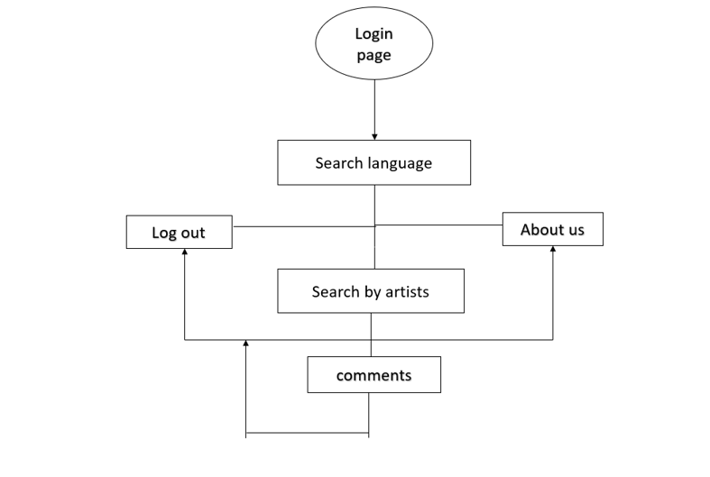

Fig 4.1 PROCESS FLOW DIAGRAM

### 4.1.LOGIN PAGE

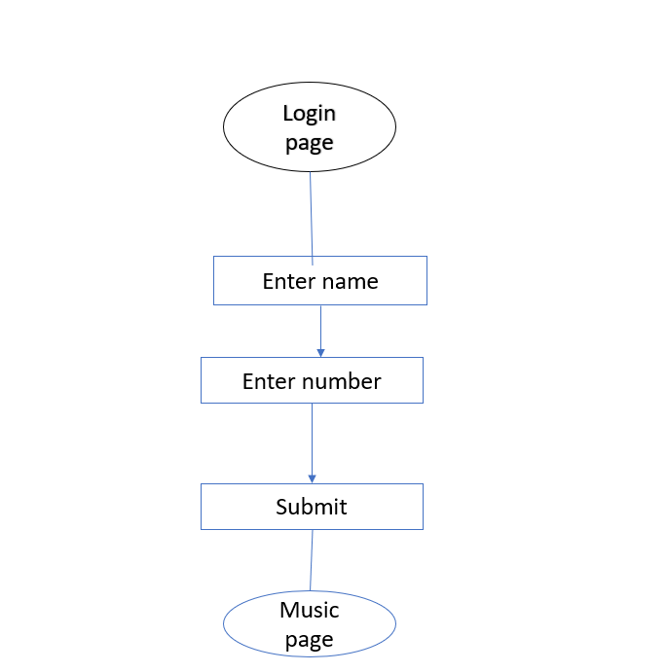

Fig 4.2. LOGIN PAGE FLOWCHART

In this page it ask about the username and password of the user. Firstly the website validates the user inputs. It verifies the username and number by checking it with the usernames and number stored in the local storage when the user creates an account in the website.

### 4.2 HOME PAGE

The homepage of a musical website is typically the first page a user sees when they visit the site. It is the gateway to the rest of the website's content and serves as a crucial interface for the user. A well-designed homepage should provide a clear and easy-to-use interface that allows users to quickly and easily find what they are looking for. Searching by language on a musical website can be a useful feature for users looking

for music in a specific language. This feature allows users to filter the website's content based on the language of the music, making it easier for users to find the music they are interested in. Overall, searching by language on a musical website can provide a more inclusive and personalized user experience, making it easier for users to find the music they want to listen to, and promoting cultural diversity and representation on the website.

**4.3 SEARCH BY ARTISTS**

Searching by artist on a musical website can be a helpful feature for users looking for specific information about a particular artist. With this feature, users can easily find all the content related to an artist, including their albums, songs, concerts, and biographical information.

### 4.4 ABOUT US

An "About Us" page on a musical website is a section that provides information about the website, its purpose, and the people behind it. It is an opportunity for the website to introduce itself to its audience and establish its credibility and trust worthiness. The history of the website, including when it was established and how it evolved over time . The mission and vision of the website, and what it aims to achieve through its content. A description of the team behind the website, including their backgrounds and roles. A list of the services and features offered by the website, such as streaming music, concert listings, and artist profiles. Contact information, such as an email address or phone number, to allow users to get in touch with the website's team.

### 4.5 COMMENT PAGE Fig 4.3 COMMENTS PAGE FLOWCHART

A comment page on a musical website is a section where users can leave their thoughts, opinions, or feedback about the website's content, such as music albums, artists, or concerts. This section allows the website to create a sense of community and interact with its users.

# IMPLEMENTATION AND RESULT



**CHAPTER 5**

**IMPLEMENTATION AND RESULT**

This chapter gives a description about the output that we produced by developing the website of our idea. Here we can get to know about the design of login page , home page comment page and about page of TUNE IN website.

### 5.1 LOGIN PAGE

When User enters our website he will be asked about his login details like email id and mobole number . The login details will be verified with the details given while the user creates an account.

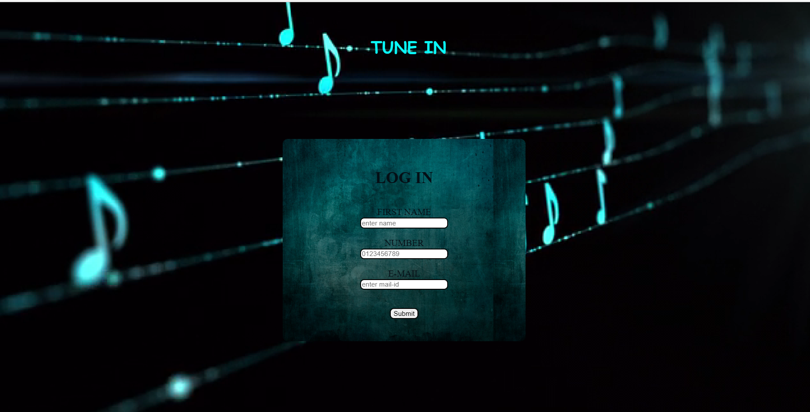

Fig 5.1 LOGIN PAGE

### 5.2 HOME PAGE

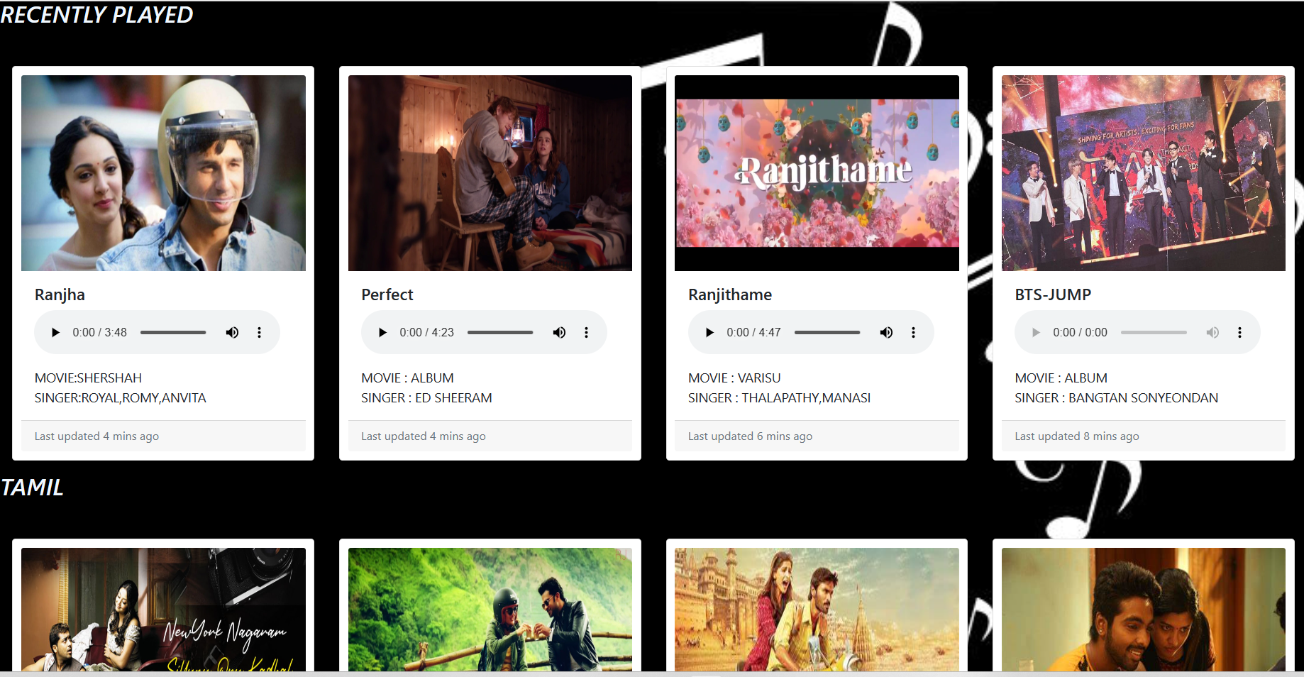

Fg 5.2 HOME PAGE

searching by language on a musical website can provide a more inclusive and personalized user experience, making it easier for users to find the music they want to listen to, and promoting cultural diversity and representation on the website.

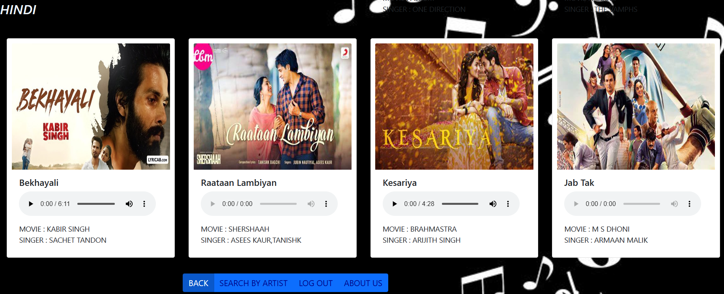

### SEARCH BY SINGERS AND DIRECTORS

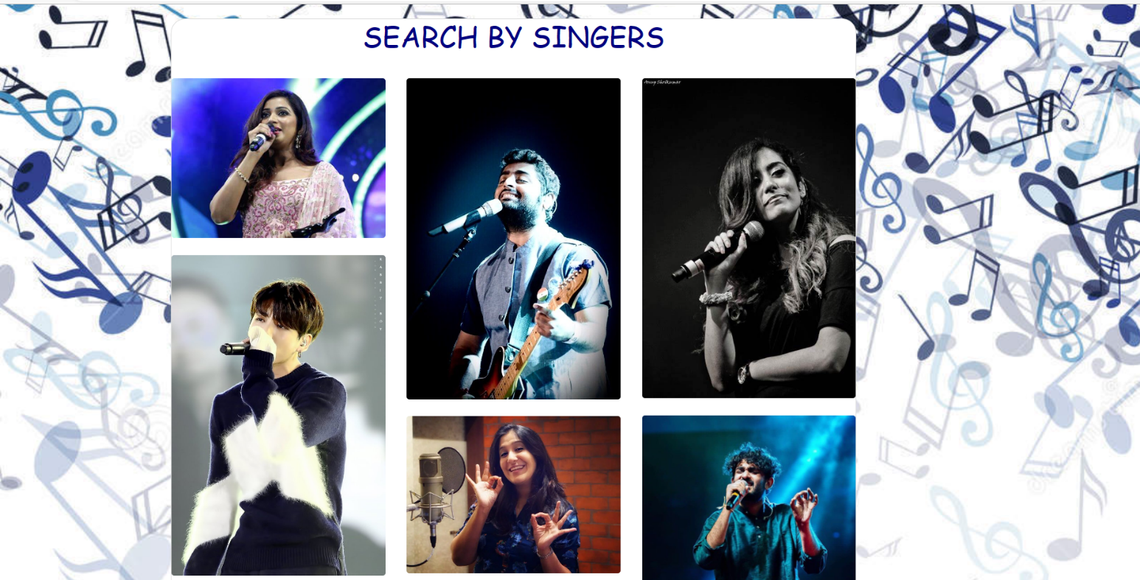

Fig 5.3 SINGERS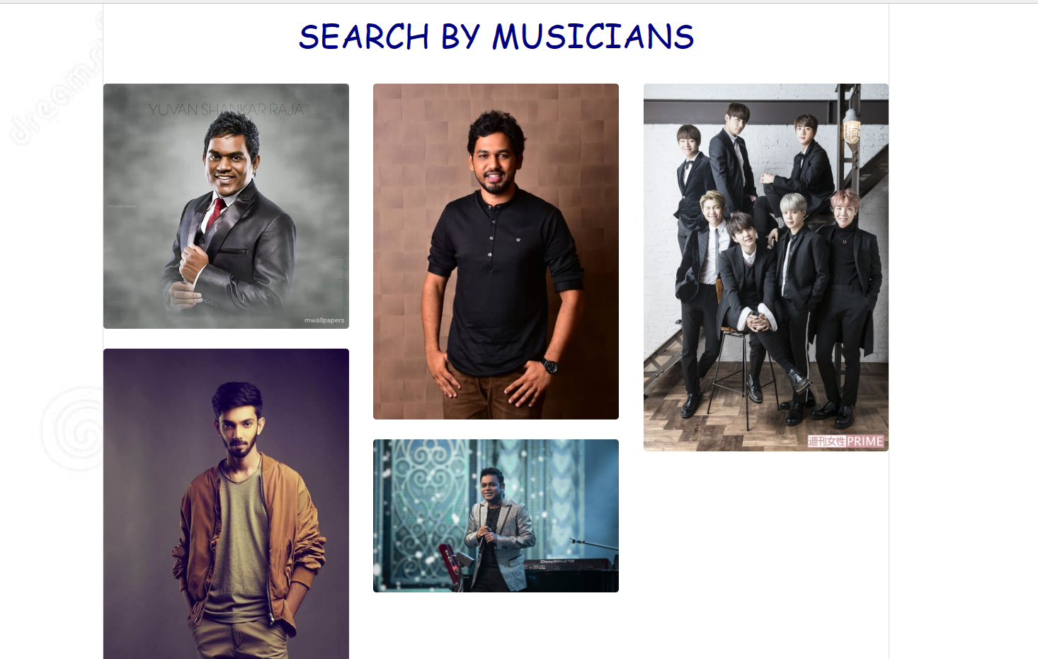 Fig 5.4 MUSICIANS

**5.4.JAVASCRIPT ALERT**

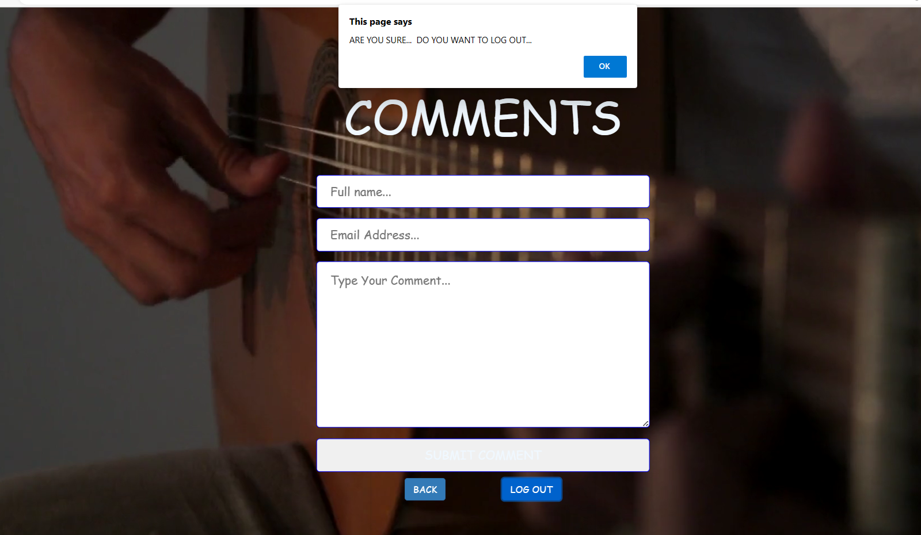

Fig 5.4 JAVASCRIPT

This java script alert message is very much required for any website . The user may unknowingly press the logout option and this helps to get notify that we are sure to log out .

### 5.5 ABOUT US

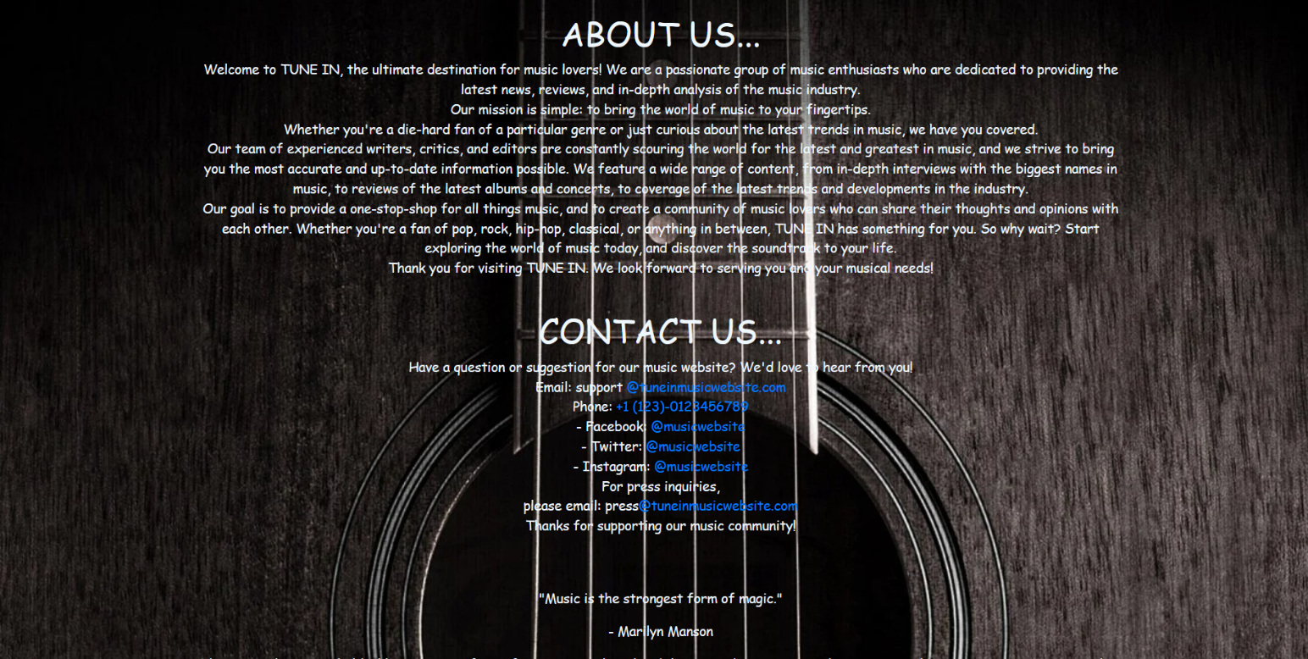

Fig 5.6 ABOUT US PAGE

The "About Us" page can be used to introduce the website to visitors. This can include an overview of the website's purpose, history, and goals. This information can help visitors to understand what the website is all about and what they can expect to find on the site.

### 5.6 COMMENTS PAGE

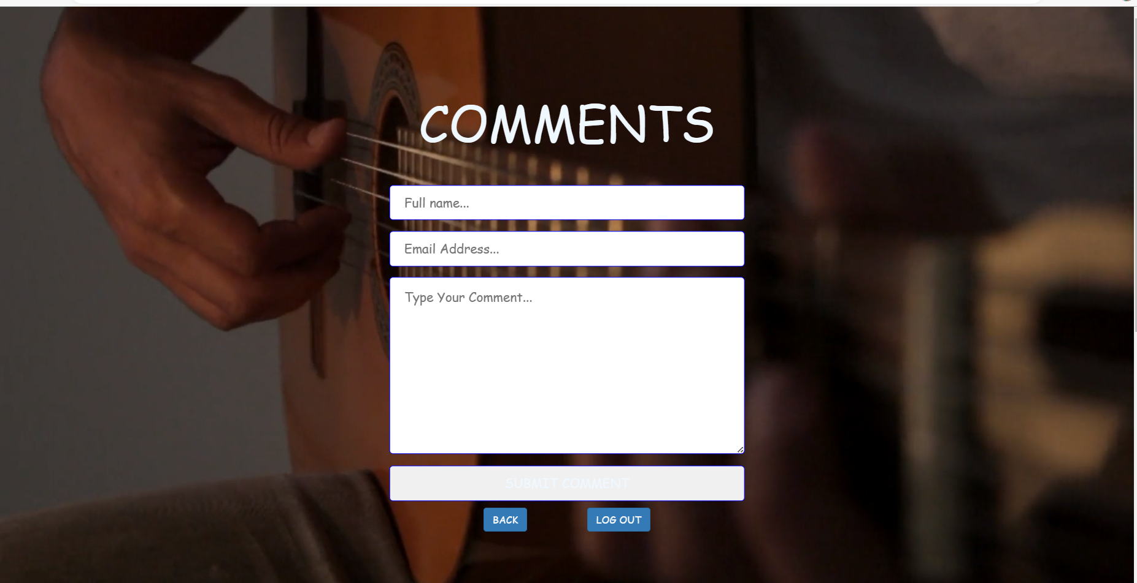

Fig 5.7 COMMENTS PAGE

The comment page can be used to encourage feedback from visitors to the website. This can include comments on music reviews, upcoming concerts, or other events. The feedback can be used to improve the website's content and provide a more engaging user experience.

### 5.7 CODING

#### Login page

#### -Html code

<html>

<head>

<title>project</title>

<link rel="stylesheet" href="page1.css">

</head>

<body>

<video id="background-video" autoplay loop muted poster="https://assets.codepen.io/6093409/river.jpg">

<source src="music.mp4" type="video/mp4">

</video>

<br><br>

<h1 class="one"><b>TUNE IN</b></h1>

<div class="card">

<br><br>

<h1 class="card-title">LOG IN</h1><br>

<form action="./page2.html">

<label for="fname">FIRST NAME</label><br>

<input type="text" placeholder="enter name" required><br><br>

<label for="lname">NUMBER</label><br>

<input type="number" placeholder="0123456789" required><br><br>

<label>E-MAIL</label><br>

<input type="email" placeholder="enter mail-id"><br><br><br>

<input type="submit" value="Submit">

</form>

</div>

</body>

</html>

**-css code**

#background-video {

width: 100vw;

height: 100vh;

object-fit: cover;

position: fixed;

left: 0;

right: 0;

top: 0;

bottom: 0;

z-index: -1;

}

.one{

color: rgb(10, 249, 249);

text-align: center;

font-family: cursive;

font-size: xx-large;

}

label{

font-size: large;

}

input{

border-radius: 8px;

border-color: black;

}

.card

{

margin-top: 10%;

margin-left: 550px ;

text-align: center;

border-radius: 10px;

width: 30rem;

height: 25rem;

color:rgb(5, 14, 21);

background-image: url(./mm.jpg);

}

**Search by language page**

**-html code**

<html>

<head>

<title>project</title>

<link rel="stylesheet" href="page2.css">

<link href="https://cdn.jsdelivr.net/npm/bootstrap@5.1.3/dist/css/bootstrap.min.css" rel="stylesheet" integrity="sha384-1BmE4kWBq78iYhFldvKuhfTAU6auU8tT94WrHftjDbrCEXSU1oBoqyl2QvZ6jIW3" crossorigin="anonymous">

</head>

<body>

<br>

<h3><i>RECENTLY PLAYED</i></h3><br>

<div class="card-group">

<div class="one">

<div class="card">

<img src="./p4.jpg" class="card-img-top" alt="...">

<div class="card-body">

<h5 class="card-title">Ranjha</h5>

<p>

<audio controls>

<source src="ranjha.mpeg" type="audio/mpeg" /><br>

<p class="card-text">

MOVIE:SHERSHAH<br>SINGER:ROYAL,ROMY,ANVITA</p>

</div>

<div class="card-footer">

<small class="text-muted">Last updated 4 mins ago</small>

</div>

</div>

</div>

<div class="one">

<div class="card">

<img src="./p2" class="card-img-top" alt="...">

<div class="card-body">

<h5 class="card-title">Perfect</h5>

<p>

<audio controls>

<source src="perfect.mpeg" type="audio/mpeg" /><br>

<p class="card-text">MOVIE : ALBUM<br>SINGER : ED SHEERAM</p>

</div>

<div class="card-footer">

<small class="text-muted">Last updated 4 mins ago</small>

</div>

</div>

</div>

<div class="one">

<div class="card">

<img src="./p3.jpg" class="card-img-top" alt="...">

<div class="card-body">

<h5 class="card-title">Ranjithame</h5>

<p>

<audio controls>

<source src="ranjithamey.mpeg" type="audio/mpeg" /><br>

<p class="card-text"> MOVIE : VARISU<br>SINGER : THALAPATHY,MANASI</p>

</div>

<div class="card-footer">

<small class="text-muted">Last updated 6 mins ago</small>

</div>

</div>

</div>

<div class="one">

<div class="card">

<img src="./bts3.jpeg" class="card-img-top" alt="...">

<div class="card-body">

<h5 class="card-title">BTS-JUMP</h5>

<p>

<audio controls>

<source src="k.mpeg" type="audio/mpeg" class="audio"/><br>

<p class="card-text">

MOVIE : ALBUM<br>SINGER : BANGTAN SONYEONDAN</p>

</div>

<div class="card-footer">

<small class="text-muted">Last updated 8 mins ago</small>

</div>

</div>

</div>

</div>

<h3><i>TAMIL</i></h3><br>

<div class="card-group">

<div class="one">

<div class="card">

<img src="./n21.jpg" class="card-img-top" alt="...">

<div class="card-body">

<h5 class="card-title">New York Nagaram</h5>

<p> <audio controls>

<source src="newyork.mpeg" type="audio/mpeg" class="audio"/><br></p>

<p class="card-text">MOVIE : SILLINU ORU KHADHAL<br>SINGER : A.R.RAHMAAN</p>

</div>

</div>

</div>

<div class="one">

<div class="card">

<img src="./n22.jpg" class="card-img-top" alt="...">

<div class="card-body">

<h5 class="card-title">Kadhaipoma</h5>

<p> <audio controls>

<source src="kadhaipoma.mpeg" type="audio/mpeg" class="audio"/><br></p>

<p class="card-text">MOVIE : OH MY KADUVULEY<br>SINGER : SID SRIRAM</p>

</div>

</div>

</div>

<div class="one">

<div class="card">

<img src="./n23.jfif" class="card-img-top" alt="...">

<div class="card-body">

<h5 class="card-title">Ambikabathy</h5>

<p> <audio controls>

<source src="ambikapathy.mpeg" type="audio/mpeg" class="audio"/><br></p>

<p class="card-text">MOVIE : AMBIKAPATHY<br>SINGER : NARESH IYER</p>

</div>

</div>

</div>

<div class="one">

<div class="card">

<img src="./n24.jfif" class="card-img-top" alt="...">

<div class="card-body">

<h5 class="card-title">Aazhi Soozhndha</h5>

<p> <audio controls>

<source src="aazhisoozhndha.mpeg" type="audio/mpeg" class="audio"/><br></p>

<p class="card-text">MOVIE : SIVAPPU MANJAL PACHCHAI<br>SINGER : SRIKANTH HARIHARAN</p>

</div>

</div>

</div>

</div>

<h3><i>ENGLISH</i></h3><br>

<div class="card-group">

<div class="one">

<div class="card">

<img src="./b1.jpg" class="card-img-top" alt="...">

<div class="card-body">

<h5 class="card-title">Baby</h5>

<p> <audio controls>

<source src="b1.jpg" type="audio/mpeg" class="audio"/><br></p>

<p class="card-text">MOVIE : ALBUM<br>SINGER : JUSTIN BIEBER</p>

</div>

</div>

</div>

<div class="one">

<div class="card">

<img src="./b2.jpg" class="card-img-top" alt="...">

<div class="card-body">

<h5 class="card-title">Let Me Love You</h5>

<p> <audio controls>

<source src="let me love you.mpeg" type="audio/mpeg" class="audio"/><br></p>

<p class="card-text">MOVIE : ALBUM<br>SINGER : JUSTIN BIEBER</p>

</div>

</div>

</div>

<div class="one">

<div class="card">

<img src="./b3.jfif" class="card-img-top" alt="...">

<div class="card-body">

<h5 class="card-title">Steal My Girl</h5>

<p> <audio controls>

<source src="k.mpeg" type="audio/mpeg" class="audio"/><br></p>

<p class="card-text">MOVIE : ALBUM<br>SINGER : ONE DIRECTION</p>

</div>

</div>

</div>

<div class="one">

<div class="card">

<img src="./b4.jpg" class="card-img-top" alt="...">

<div class="card-body">

<h5 class="card-title">Somebody To You </h5>

<p> <audio controls>

<source src="k.mpeg" type="audio/mpeg" class="audio"/><br></p>

<p class="card-text">MOVIE : ALBUM<br>SINGER : THE VAMPHS</p>

</div>

</div>

</div>

</div>

<h3><i>HINDI</i></h3><br>

<div class="card-group">

<div class="one">

<div class="card">

<img src="./m31.jpg" class="card-img-top" alt="...">

<div class="card-body">

<h5 class="card-title">Bekhayali</h5>

<p> <audio controls>

<source src="bekhayali.mpeg" type="audio/mpeg" class="audio"/><br></p>

<p class="card-text">MOVIE : KABIR SINGH<br>SINGER : SACHET TANDON</p>

</div>

</div>

</div>

<div class="one">

<div class="card">

<img src="./m32.jfif" class="card-img-top" alt="...">

<div class="card-body">

<h5 class="card-title">Raataan Lambiyan</h5>

<p> <audio controls>

<source src="k.mpeg" type="audio/mpeg" class="audio"/><br></p>

<p class="card-text">MOVIE : SHERSHAAH<br>SINGER : ASEES KAUR,TANISHK</p>

</div>

</div>

</div>

<div class="one">

<div class="card">

<img src="./m33.jfif" class="card-img-top" alt="...">

<div class="card-body">

<h5 class="card-title">Kesariya</h5>

<p> <audio controls>

<source src="kesariya.mpeg" type="audio/mpeg" class="audio"/><br></p>

<p class="card-text">MOVIE : BRAHMASTRA<br>SINGER : ARIJITH SINGH</p>

</div>

</div>

</div>

<div class="one">

<div class="card">

<img src="./m34.jfif" class="card-img-top" alt="...">

<div class="card-body">

<h5 class="card-title">Jab Tak</h5>

<p> <audio controls>

<source src="k.mpeg" type="audio/mpeg" class="audio"/><br></p>

<p class="card-text">MOVIE : M S DHONI<br>SINGER : ARMAAN MALIK</p>

</div>

</div>

</div>

</div>

<div class="btn-group" id="man">

<a href="page1.html" class="btn btn-primary active">BACK</a>

<a href="page3.html" class="btn btn-primary">SEARCH BY ARTIST</a>

<a href="page1.html" class="btn btn-primary">LOG OUT</a>

<a href="about.html" class="btn btn-primary">ABOUT US</a>

</div>

</body>

</html>

**SEARCH BY ARTIST**

**-html code**

<html>

<head>

<title>artist</title>

<link rel="stylesheet" href="https://stackpath.bootstrapcdn.com/bootstrap/4.5.2/css/bootstrap.min.css" integrity="sha384-JcKb8q3iqJ61gNV9KGb8thSsNjpSL0n8PARn9HuZOnIxN0hoP+VmmDGMN5t9UJ0Z" crossorigin="anonymous">

<link rel="stylesheet" href="page3.css">

</head>

<body>

<div class="btn-group" id="man">

<a href="page1.html" class="btn btn-primary active">LOGIN PAGE</a>

<a href="page2.html" class="btn btn-primary">SEARCH BY LANGUAGE</a>

<a href="about.html" class="btn btn-primary">ABOUT US</a>

<a href="com.html" class="btn btn-primary">COMMENT</a>

<a href="page1.html" class="btn btn-primary">LOG OUT</a>

</div>

<div class="card">

<h1>

SEARCH BY SINGERS

</h1><br>

<div class="row">

<div class="col-lg-4 col-md-12 mb-4 mb-lg-0">

<img

src="https://th.bing.com/th/id/OIP.zTUyjrIu3jfpG4m6GNb57wHaFj?pid=ImgDet&rs=1"

class="w-100 shadow-1-strong rounded mb-4" />

<img

src="https://th.bing.com/th/id/R.fab75b7a6efe7205497cad39d38e6301?rik=tVdgJyuZEjfmDQ&riu=http%3a%2f%2fimages6.fanpop.com%2fimage%2fphotos%2f39600000%2fJeon-Jungkook-HQ-Photo-jungkook-bts-39645349-600-900.jpg&ehk=Y5DglGU4xd%2bodaSwGqGi7j59ShDDuQdkq1ck9cak1rw%3d&risl=&pid=ImgRaw&r=0"

class="w-100 shadow-1-strong rounded mb-4"

/>

</div>

<div class="col-lg-4 mb-4 mb-lg-0">

<img

src="https://i.pinimg.com/originals/f1/75/eb/f175eb4e1806f055f7ea35622e773424.jpg"

class="w-100 shadow-1-strong rounded mb-4"/>

<img

src="https://i0.wp.com/photos.omfmedia.com/wp-content/uploads/2019/10/38DA9DBC-2DCC-4E7C-B0FF-D0DC12F99601.jpeg?fit=1080%2C795&ssl=1"

class="w-100 shadow-1-strong rounded mb-4" />

</div>

<div class="col-lg-4 mb-4 mb-lg-0">

<img

src="https://th.bing.com/th/id/OIP.PGUoQQioWv2yfBupCwOunAHaLG?pid=ImgDet&rs=1" class="w-100 shadow-1-strong rounded mb-4" />

<img

src="https://i.pinimg.com/originals/fd/b2/f9/fdb2f984b7ad68936faef2609c60a9e7.jpg"

class="w-100 shadow-1-strong rounded mb-4" />

</div>

</div>

<h1>

SEARCH BY MUSICIANS

</h1><br>

<div class="row">

<div class="col-lg-4 col-md-12 mb-4 mb-lg-0">

<img

src="https://th.bing.com/th/id/OIP.f8FoJcNj3-ON3xkVoV60ngHaHa?pid=ImgDet&rs=1"

class="w-100 shadow-1-strong rounded mb-4"

/>

<img

src="https://th.bing.com/th/id/OIP.jdvyPuKmYhM_SxvJ5Yve0AHaLH?pid=ImgDet&rs=1"

class="w-100 shadow-1-strong rounded mb-4” />

</div>

<div class="col-lg-4 mb-4 mb-lg-0">

<img

src="https://www.wikibionet.com/wp-content/uploads/2020/09/Adhi-Hiphop-Tamizha.jpg"

class="w-100 shadow-1-strong rounded mb-4" />

<img

src="https://im.whatshot.in/img/2020/Jan/-78a4812-cropped-1578483601.jpg"

class="w-100 shadow-1-strong rounded mb-4 />

</div>

<div class="col-lg-4 mb-4 mb-lg-0">

<img

src="https://i.pinimg.com/736x/a3/20/ce/a320ce30be20f1a015cf5874d62c59db--kpop-groups-bts-bangtan-boy.jpg"

class="w-100 shadow-1-strong rounded mb-4"/>

</div>

</div>

</div>

</body>

</html>

# CONCLUSION



## CHAPTER 6 CONCLUSION

This chapter tells about the conclusion that anyone can drive from the project .

### CONCLUSION

TUNE IN musical website is a platform that provides music lovers with a comprehensive and immersive experience. With a user-friendly interface, a modern design, and a wide range of music-related content and features, a musical website can offer a one-stop-shop for discovering and enjoying music. From searching and streaming songs and albums, to creating playlists, reading lyrics and artist information, to connecting with other music lovers, a musical website has something for everyone. The proposed system for a musical website aims to provide a seamless and enjoyable experience for music lovers, allowing them to connect with their favorite artists, albums, and songs in a variety of ways. By providing a platform that is both comprehensive and user-friendly, a musical website has the potential to become a go-to destination for music lovers everywhere.

### FUTURE SCOPE

The future scope of a musical website is vast and holds many opportunities for growth and innovation. Here are some of the ways that a musical website can expand and evolve in the future. Integrating social media platforms like Facebook, Instagram, and Twitter into the musical website can allow users to share their playlists, connect with friends, and engage with other music lovers the future scope of a musical website is exciting and holds many opportunities for growth and innovation. With the integration of new technologies and the expansion of its offerings, a musical website can continue to provide music lovers with a comprehensive and enjoyable experience for years to come.

# REFERENCES



### REFERENCES

1. Spotify - https://www.spotify.com/

2. Apple Music - <https://www.apple.com/music/>

3. W3Schools - https://www.w3schools.com/sss

W3Schools is a comprehensive and easy-to-use online platform for learning web development technologies, including HTML and CSS. They offer tutorials, examples, and quizzes to help you learn and practice your skills.

4. Bootstrap Official Website - https://getbootstrap.com/

The official website for Bootstrap, a popular front-end framework for building responsive and mobile-friendly websites. It provides documentation, tutorials, examples, and resources for using Bootstrap.s